

**Discovering Knowledge**

**COURSE: SEL-448**

**Software application For Mobile Devices LAB**

**PROJECT REPORT**

**CLASS: BSE – 6B (SPRING - 2024)**

Healthcare Application

**Group Members**

|  |  |
| --- | --- |
| **Student Name** | **Enrollment#** |
| Ahsan Sajjad | 02-131212-049 |
| Adeeb ul Hassan | 02-131212-002 |
| Mutayyab Imran | 02-131212-063 |

**Submitted to:**

**Course Instructor:** Engr Adnan ur Rahman

**Lab Instructor:** Engr. Hamza

**Department of Software Engineering**

TABLE OF Contents

1. Introduction 3

2. Problem Statement 3

3. Proposed Solution 3

3.1. Features of the project 3

3.2. Methodology 4

3.3. Technologies 04

4. Software Design Description 04

4.6. Technologies 04

4.8. Screen Images 05

5. Project Scope 05

6. Module Distribution 05

8. Conclusion 06

9. References 06

# Introduction

Healthcare applications are becoming increasingly vital in today's fast-paced world, where individuals require convenient access to medical services and information. Our project aims to develop a comprehensive healthcare application for Android devices, leveraging the power of technology to provide users with seamless access to various healthcare services and resources. The background of this project stems from the growing demand for accessible healthcare solutions. With the advancement of technology and the widespread use of smartphones, there is a significant opportunity to bridge the gap between healthcare providers and patients through mobile applications.

# Problem Statement

Traditional healthcare systems often face challenges such as long wait times, limited accessibility, and fragmented information. Patients may struggle to find suitable doctors, schedule appointments, or access essential medical resources efficiently. Additionally, managing medical records and tracking health-related activities can be cumbersome for individuals. There is a need for a comprehensive healthcare application that addresses these challenges by providing users with a user-friendly platform to access various healthcare services, such as finding doctors, scheduling appointments, ordering lab tests and medicines, accessing health articles, and managing health-related information effectively.

# Proposed Solution

**Key Features:**

* Login and Registration: Secure authentication system for users to access the application.
* Lab Test: Browse and order lab test packages, add to cart, and make orders.
* Find Doctor: Search for specialist doctors, view profiles, and book appointments.
* Health Articles: Access informative articles on various health topics.
* Order Details: View details of past and current orders.
* Logout: Securely log out of the application.

## Methodology

Our methodology for developing the comprehensive healthcare application for Android devices involved several critical phases, including planning, design, development, testing, and deployment. Each phase was meticulously executed to ensure the creation of a user-friendly, secure, and efficient application that meets the needs of both patients and healthcare providers.

**Planning**

* Identify key requirements.
* Conduct market research and stakeholder consultations.
* Define project scope.

**Design**

* Create intuitive UI/UX.
* Develop wireframes and prototypes.
* Ensure accessibility and ease of navigation.

**Development**

* Implement features (secure login, lab test ordering, etc.) using agile methodology.
* Conduct regular code reviews.

**Testing**

* Perform unit, integration, and user acceptance testing.

## Technologies

**Android Studio**

* **Description**: Android Studio is the official Integrated Development Environment (IDE) for Android application development. It provides a comprehensive suite of tools for coding, debugging, and testing Android apps, ensuring efficient and streamlined development processes.

**Java**

* **Description**: Java is a versatile and widely-used programming language employed for the backend and application logic. It enables robust and secure code development, facilitating seamless interaction between the application's frontend and backend components.

**XML**

* **Description**: XML (Extensible Markup Language) is utilized for designing user interfaces in Android applications. It allows for a clear and structured definition of UI elements, ensuring that the application’s layout is both intuitive and visually appealing.

# Software Design Description

## Design Overview

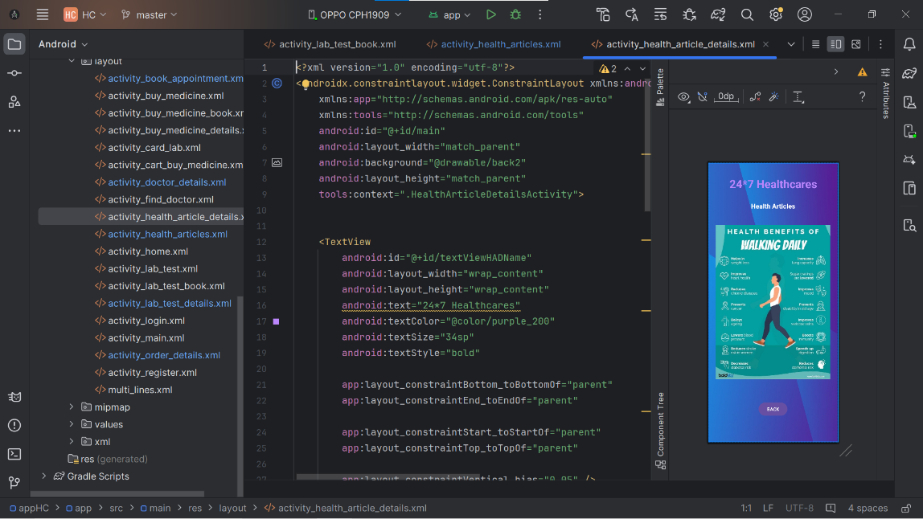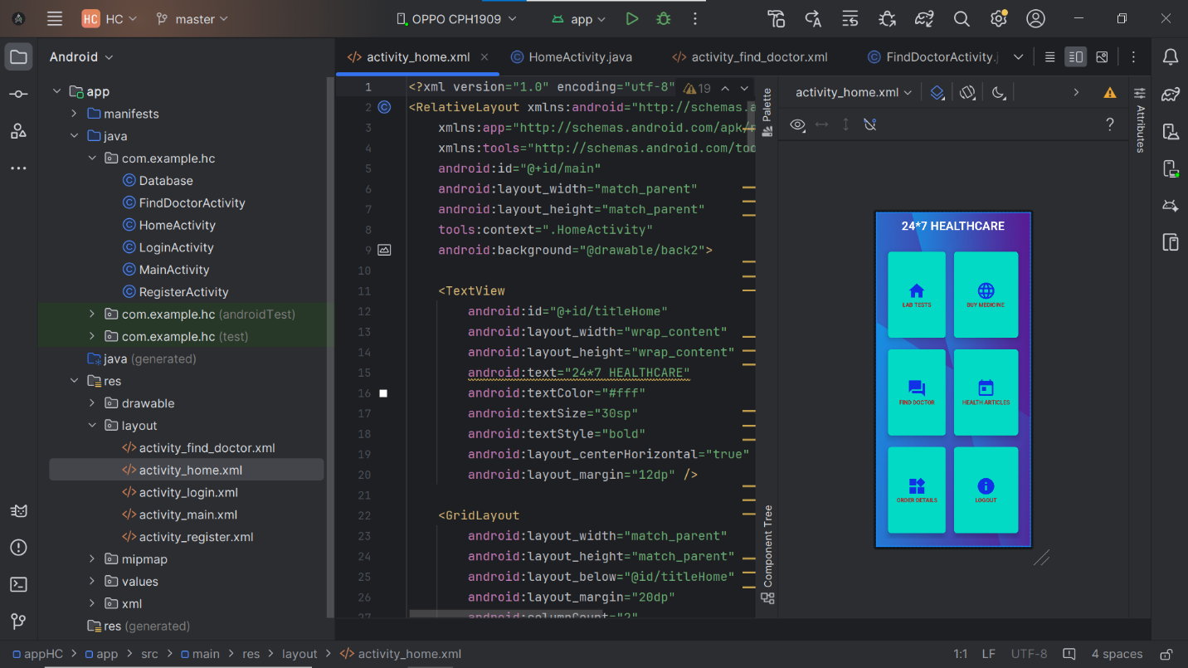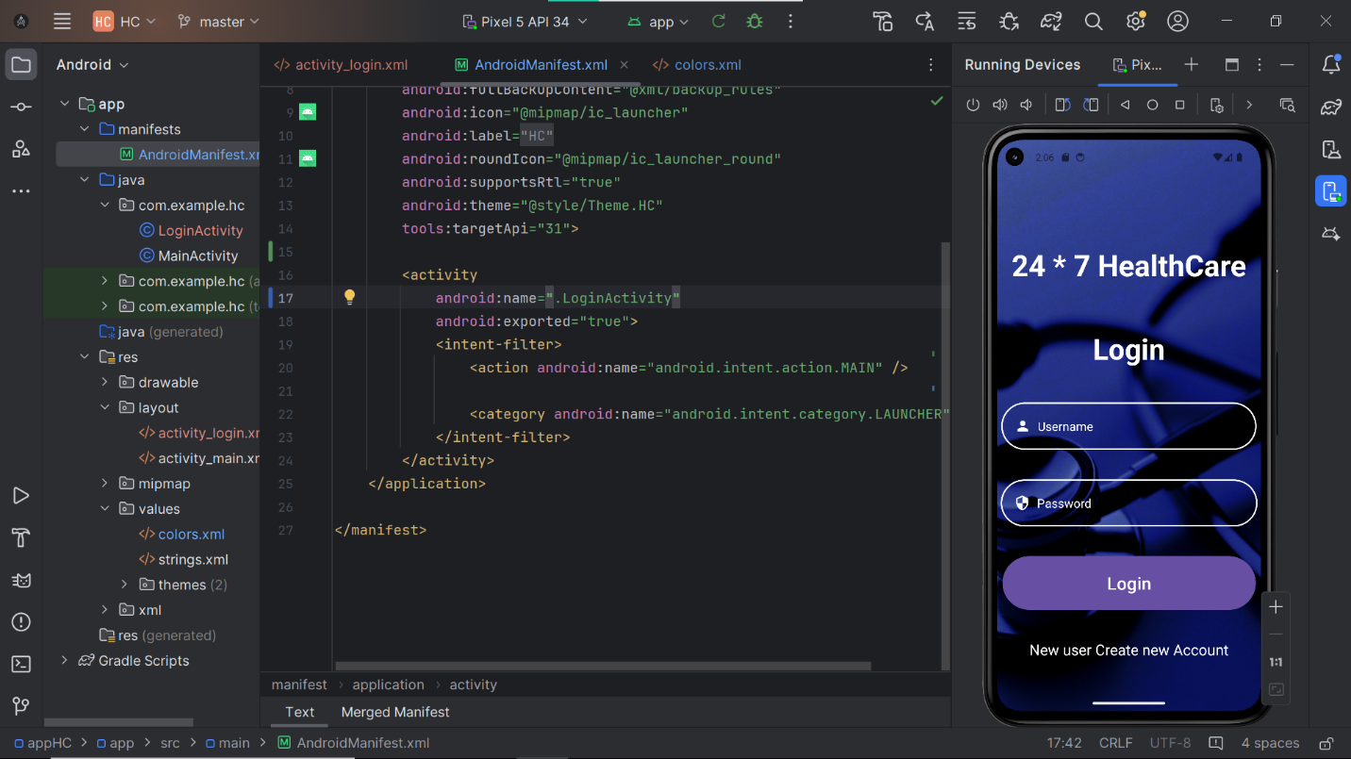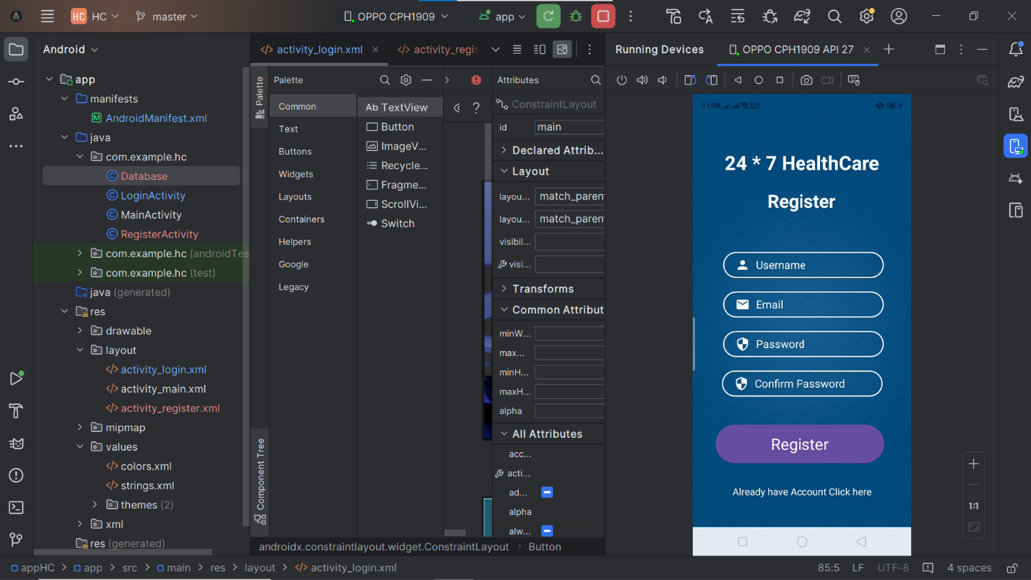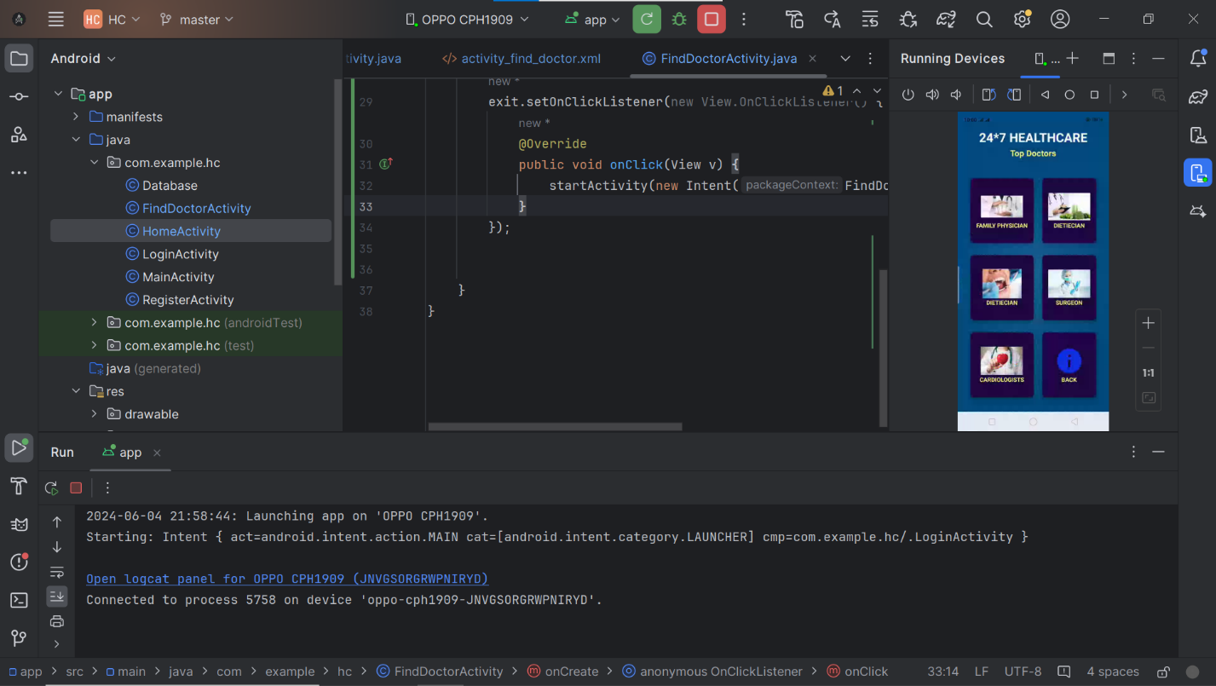

# Project Scope

The scope of this project involves the development of a comprehensive healthcare application for Android devices, designed to provide a wide array of healthcare services and resources to users. The project is structured to ensure a robust and scalable application that can evolve with user needs and technological advancements. The detailed scope includes:

**Login and Registration**: Implementing a secure authentication system that allows users to create accounts and log in safely.

* **Lab Test Ordering**: Enabling users to browse, select, and order lab test packages, add them to a cart, and complete orders.
* **Medicine Purchase**: Allowing users to view a list of available medicines, add desired items to a cart, and place orders.
* **Doctor Search and Appointment Booking**: Providing a search feature for users to find specialist doctors, view their profiles, and book appointments directly through the app.
* **Health Articles**: Offering access to a library of informative health articles on various topics to educate and inform users.
* **Order Details Management**: Enabling users to view details of their past and current orders for lab tests and medicines.
* **Logout Functionality**: Implementing a secure logout feature to ensure user data privacy and security.

# Module Distribution

|  |  |
| --- | --- |
| **Student Name** | **Module Disturbution** |
| Mutayyab Imran | Backend Development (Java) |
| Ahsan Sajjad | Frontend Development (Android Studio, XML) |
| Adeeb ul Hassan Siddiqui | Database + java |

# Code

You Can find the code here.

[Project Code](https://github.com/AhsanSajjadpk/Healthcare-App.git)

# Conclusion

In conclusion, this project aims to develop a comprehensive healthcare application for Android devices, addressing the challenges of traditional healthcare systems. By offering features like lab test ordering, medicine purchase, doctor appointment booking, and health article access, the app will provide users with convenient and efficient access to healthcare services. Initial releases will focus on core functionalities, with future updates based on user feedback and resources.

# References

<https://www.dbswebsite.com/blog/examples-of-great-healthcare-apps/>

<https://youtu.be/9CkpMm-n5iA?si=26g8720FIRqEgX9z>